

PROJECT REPORT

PROJECT TITLE

YEAR : 2025 – 20226
COLLEGE NAME : K.C.S KASI NADAR COLLEGE OF ARTS & SCIENCE
CODE : UNM203
DEPARTMENT : COMPUTER SCIENCE
PROGRAM : B.C.A
SEMESTER : V
PROJECT SUBMITTED TO: UNIVERSITY OF MADRAS /
VETRI THIRAN PAYIRCHI THITTAM
Course Name : AI Augmented Backend Development with
Node JS and MongoDB

TEAM LEADER:
HEMAPRIYA B
MEMBERS:
- CHARUHASINI R
2. JAYASREE R
3. JANANI R
GUIDED BY: Mrs. R.PADMADEVI
SPOC NAME: Dr.K. LALITHAKAMESWARI

FITTRACK AI
Personalized Fitness Recommendations Powered by AI
Elaborated Project / Seminar Documentation

Project Type | AI-powered RESTful Fitness Tracking Backend
Architecture | Model–View–Controller (MVC)
Backend | Node.js + Express.js
Database | MongoDB + Mongoose
Security | JWT Authentication + bcrypt.js
AI Integration | Google Gemini AI

Contents
A structured route through the project, designed for seminar presentation.

No. | Section
1 | Executive Summary
2 | Introduction and Scenario-Based Case Study
3 | Problem Statement and Proposed Solution
4 | Objectives and Scope
5 | Technology Stack and Requirements
6 | System Architecture
7 | Major Components and Responsibilities
8 | MVC Architecture
9 | Database Design and Data Model
10 | Core Features
11 | REST API Design
12 | Authentication and Security Flow
13 | Workout Management and Search
14 | Google Gemini AI Integration
15 | AI Fitness Insights
16 | API Testing Strategy
17 | API Testing – Authentication Outputs
18 | API Testing – Workout Outputs
19 | API Testing – AI Outputs
20 | Error Handling, Validation and Reliability
21 | Advantages, Limitations and Future Enhancements
22 | Conclusion and Seminar Talking Points

Executive Summary
FitTrack AI is a secure, scalable and AI-powered RESTful backend designed to simplify workout tracking and provide intelligent fitness guidance. The supplied project document describes a Node.js and Express.js backend connected to MongoDB through Mongoose, with JWT-based authentication and bcrypt.js password protection. Google Gemini AI is used for personalized workout recommendations and fitness insights.
The system is organized using an MVC-based layered architecture. A client such as a React application, mobile application or Postman/Thunder Client sends HTTP requests to the Express server. Protected requests pass through JWT authentication middleware. Controllers process the request, services handle reusable business logic and AI communication, and Mongoose models communicate with MongoDB. The final result is returned as a structured JSON response.

Key capabilities:
- User registration, secure login and profile access.
- JWT-protected workout APIs.
- Create, read, update and delete workout records.
- Workout search by name, category or date.
- AI-generated workout recommendations using age, fitness goal and experience.
- AI-generated fitness insights using total workouts, average duration and calories burned.
- Standardized JSON responses and centralized error handling.

Introduction and Scenario-Based Case Study
The project document presents a practical scenario
in which Rahul, a fitness enthusiast, records workouts manually using notebooks and spreadsheets. Although he exercises consistently, manual records make it difficult to organize history, monitor progress and decide which workouts fit his current fitness level.
The scenario identifies a gap between regular exercise and intelligent digital tracking. FitTrack AI addresses that gap by providing one backend system for authentication, workout management and AI guidance.
The original project description states that the backend is intended to be integrated with web, mobile and third-party applications through REST APIs.

Scenario Area | Existing Difficulty | FitTrack AI Response
Workout records | Scattered notebook/spreadsheet records | Centralized MongoDB workout records
Authentication | No secure personal access mechanism | JWT-based protected APIs
History | Difficult to retrieve older workouts | Get, search and get-by-ID APIs
Editing | Manual correction | Update API
Deletion | Manual record removal | Delete API
Guidance | No personalized recommendations | Google Gemini recommendation API
Progress understanding | Manual calculations | AI fitness insights

Problem Statement and Proposed Solution
Problem Statement
- Difficulty maintaining a centralized record of workouts.
- Manual tracking can lead to inaccurate workout history.
- Lack of secure authentication for personal fitness records.
- Difficulty searching previous workouts efficiently.
- No personalized workout recommendations.
- No automated insight into overall workout performance.
- Manual calculation of workout duration and calories can be time-consuming.

Proposed Solution
FitTrack AI provides a centralized backend in which a registered user can authenticate and manage workout records through RESTful APIs. The system supports adding, retrieving, searching, updating and deleting workouts. A dedicated AI service communicates with Google Gemini to produce recommendations and fitness insights.

The solution also applies security and maintainability practices described in the source document:
- JWT authentication and authorization middleware.
- bcrypt.js password hashing before storage.
- Mongoose schema validation.
- Centralized error handling.
- Separation of routes, controllers, services, models and middleware.
- Environment variables for sensitive configuration.

Objectives and Scope
Objectives
- Create a secure backend for personal fitness tracking.
- Provide a clean REST API for workout operations.
- Protect personal workout data using JWT authentication.
- Store user and workout data using MongoDB and Mongoose.
- Enable workout history retrieval and search.
- Integrate Google Gemini AI for personalized recommendations.

- Generate AI-assisted fitness insights from workout statistics.
- Keep the architecture modular so future features can be added without major restructuring.
Project Scope
Included | Purpose
Authentication | Register, login and profile retrieval
Workout CRUD | Create, retrieve, update and delete workout records
Search | Find workouts using name, category or date
AI Recommendation | Generate personalized workout suggestions
AI Insights | Analyze workout statistics and return fitness guidance
Database | Persist users and workouts
API Testing | Verify request/response behavior through Postman or Thunder Client

Technology Stack and Requirements
Software Requirements
Technology | Role in FitTrack AI
Windows 10/11, macOS or Linux | Development and execution environment
Node.js v16+ | Runtime for server-side JavaScript
npm v8+ | Dependency/package management
Express.js | HTTP routing and REST API framework
MongoDB | NoSQL database for users and workouts
Mongoose | ODM layer, schemas and database operations
Postman / Thunder Client | API testing
Visual Studio Code | Development environment
Google Gemini AI | Personalized  recommendations and fitness insights
JWT | Authentication token mechanism
bcrypt.js | Password hashing

Hardware Requirements
- Processor: Intel Core i5 (8th Gen or above), AMD Ryzen 5 or equivalent.
- RAM: 8 GB minimum; 16 GB recommended for concurrent services.
- Storage: 1 GB of available project workspace.

Project Setup
- Create the project folder: AI-FitTrack-API.
- Open it in Visual Studio Code.
- Create a server folder for backend source code.
- Initialize the Node project with npm.
- Install Express, Mongoose, dotenv, bcryptjs, jsonwebtoken and cors.
- Install Nodemon as a development dependency.
- Store PORT, MONGO_URI, JWT_SECRET
and GEMINI_API_KEY in environment variables.

System Architecture
The FitTrack AI backend follows a layered architecture based on the MVC design pattern. The architecture separates routing, business logic, database interaction, middleware and AI services into independent modules.

Request flow:
- Client sends an HTTP request.
- Express server receives and parses the request.
- The route maps the request to the appropriate controller.
- For protected APIs, JWT middleware validates the Authorization token.
- The controller validates input and calls the required service/model.
- Mongoose communicates with MongoDB when database access is needed.

- The Gemini service is invoked when AI processing is required.
- The controller returns a structured JSON response.
Client  React / Mobile / Postman | Express Server | Routes + Middleware | Controllers + Services | MongoDB / Gemini AI

Major Components and Responsibilities

Component | Main Responsibility
Client Layer | Sends requests, stores JWT,  displays JSON responses and invokes AI APIs.
Express Server Gateway | Starts HTTP server, parses JSON, enables CORS, registers routes and handles  centralized errors.
Authentication Middleware | Reads Authorization header, verifies JWT and rejects

 | unauthorized requests.
Route Layer | Maps API endpoints to controller methods.
Controller Layer | Validates requests, invokes business logic and creates JSON responses.
Service Layer | Reusable business logic, JWT functions, password functions  and Gemini communication.
Database Layer | MongoDB persistence  through Mongoose models.
Gemini AI Service | Prepares prompts, sends them  to Gemini and formats AI responses.

API Route Groups

Group | Documented Operations
Authentication | Register User, Login User, User Profile
Workout | Add Workout, Get All Workouts, Search Workouts, Get Workout by ID, Update Workout, Delete Workout
AI | Workout Recommendation, Fitness Insights

MVC Architecture
Model Layer
The Model Layer defines data structures using Mongoose schemas and communicates directly with MongoDB. The documented models are User and Workout. Responsibilities include schema definition, validation, CRUD operations and collection mapping.

View Layer
Because FitTrack AI is a backend REST API, it does not use traditional server-rendered UI templates. The View is represented by API consumers such as a React application, mobile application, Postman or Thunder Client. These clients send HTTP requests and receive JSON responses.

Controller Layer
Controllers form the bridge between the API interface and the data/business layers. They validate requests, execute business logic, invoke database or AI services and generate structured responses.

MVC in One Line
View/API consumer → Controller → Model/Service → Database or AI → Controller → JSON response

Database Design and Data Model
MongoDB is the primary NoSQL database. Mongoose provides schema definitions, validation, relationships and database methods. The documented database contains two primary collections: Users and Workouts.

User EntitY

Field | Type | Purpose
_id | ObjectId | Primary key
name | String | User name
email | String | Unique email address
password | String | Encrypted password
createdAt | Date | Record creation time
updatedAt | Date | Last update time

Workout Entity

Field | Type | Purpose
_id | ObjectId | Primary key
user | ObjectId | Reference to User
workoutName | String | Workout name
category | String | Workout category
duration | Number | Duration in minutes
caloriesBurned | Number | Calories burned
workoutDate | Date | Workout date
createdAt / updatedAt | Date | Timestamps
Relationship: User → Workout is one-to-many. One authenticated user can create multiple workout records, while each workout belongs to one authenticated user.

Core Features
Secure Authentication — Registration, login, password hashing, JWT generation and protected APIs.
Workout Management — Complete CRUD operations for adding, viewing, updating and deleting workouts.
Workout Search — Search by workout name, category or workout date.
Google Gemini Integration — Generate personalized workout plans, exercise suggestions, training tips and safety recommendations.
AI Fitness Insights — Analyze total workouts, average duration and calories burned to produce progress and improvement guidance.
Centralized Error Handling — Meaningful JSON responses for invalid credentials, missing tokens, validation problems, database errors and internal server errors.
RESTful Design — Uses GET, POST, PUT and DELETE methods with JSON responses.
Modular Architecture — Separates models, controllers, routes, middleware, services and configuration.

- REST API Design
The screenshots supplied with this project show the API being exercised through the Thunder Client extension inside Visual Studio Code. The backend runs on localhost:5000 in the demonstrated tests.

Method | Endpoint | Purpose | Authentication
POST | /api/auth/register | Create a user  account | Public
POST | /api/auth/login | Authenticate user and issue JWT | Public
GET | /api/auth/profile | Retrieve  authenticated profile | JWT
POST | /api/workouts | Create workout | JWT
GET | /api/workouts | Get all workouts | JWT
GET | /api/workouts/search?q=... | Search workouts | JWT
GET | /api/workouts/:id | Get one workout | JWT
PUT | /api/workouts/:id | Update workout | JWT
DELETE | /api/workouts/:id | Delete workout | JWT
POST | /api/ai/workout-recommendation | Generate AI workout recommendation | JWT
POST | /api/ai/fitness-insights | Generate AI fitness  insights | JWT

API Testing Convention
For protected endpoints, the client includes a valid JWT in the Authorization header. Request bodies are sent as JSON and the server returns JSON responses.

- Authentication and Security Flow

Registration
The user sends name, email and password to the registration endpoint. The documented design requires the name and password, keeps email unique and encrypts the password using bcrypt.js before storage.

Login
The user submits email and password. After successful authentication, the backend generates a JWT token. The token is then used to authorize protected API requests.

Protected Request
- Client places the JWT in the Authorization header.
- Authentication middleware reads the header.
- The JWT signature is verified.
- User information is decoded and attached to the request.
- Invalid or missing authentication causes the request to be rejected.
Security Layers
JWT protects API access; bcrypt.js protects stored passwords; Mongoose validates data; middleware centralizes authorization; environment variables keep secrets such as JWT_SECRET and GEMINI_API_KEY out of source code.

- Workout Management and Search
CRUD Lifecycle
Operation | HTTP | Endpoint | Purpose
Create | POST | /api/workouts | Add a new workout
Read all | GET | /api/workouts | Retrieve workout history
Read one | GET | /api/workouts/:id | Retrieve one workout by identifier
Update | PUT | /api/workouts/:id | Change existing workout data
Delete | DELETE | /api/workouts/:id | Remove a workout

Search
The project document specifies search by workout name, category or workout date. This allows a user to find relevant history without manually browsing every stored record.
Example workout data used in the supplied output screenshots:
Field | Example
Workout name | Running
Category | Cardio
Duration | 30 minutes in one demonstrated request; 45 minutes in the update demonstration
Calories burned | 250

- Google Gemini AI Integration
One of the distinguishing features of FitTrack AI is the dedicated AI service layer. The documented implementation sends user fitness information to Google Gemini and returns personalized guidance.
Recommendation Inputs
- Age
- Fitness Goal
- Experience Level
Recommendation Outputs
- Personalized workout plan
- Weekly exercise suggestions
- Beginner / Intermediate / Advanced recommendations
- Motivational guidance
- Safety tips
Demonstrated Request
Input | Value shown in supplied output
Age | 21
Fitness goal | weightloss
Experience | beginner

The corresponding Thunder Client screenshot is inserted in the API testing section so that the request and its returned AI response can be shown during a seminar.

- AI Fitness Insights
The fitness-insights API analyzes summary statistics from the user's workout history. The source document identifies three primary inputs: total workouts, average workout duration and total calories burned.

Input | Demonstrated value
Total workouts | 12
Average duration | 45 minutes
Total calories burned | 3500

Expected AI insight areas:
- Performance analysis.
- Improvement suggestions.
- Motivational advice.
- Fitness progress summary.
Why This Matters
The feature moves the system beyond storing data. It turns workout statistics into a human-readable fitness interpretation, while keeping the AI interaction behind a dedicated service layer.

- API Testing Strategy
The supplied project document specifies API testing using Postman or the Thunder Client extension in Visual Studio Code. Testing is organized into three groups: Authentication APIs, Workout APIs and AI APIs.

Testing Stage | APIs Covered | Evidence included in this document
1. Authentication | Register, Login, Profile | Screenshots for Register and Login; Profile screenshot from the supplied project document
2. Workout | Add, Get All, Get by ID, Update, Delete, Search | Screenshots for Add, Update and Delete; Get All and Get by ID screenshots from the supplied project document
3. AI | Workout Recommendation, Fitness  Insights | Supplied screenshots for both AI endpoints
The screenshots are placed directly under the relevant API test so a seminar audience can see where each output belongs.
Where the supplied images do not contain a screenshot for a documented endpoint, the endpoint is described without inventing an output.

- API Testing – Authentication Outputs
  - Register User

Field | Example
name | hemapriya
email | test123@gmail.com
password | 123456789
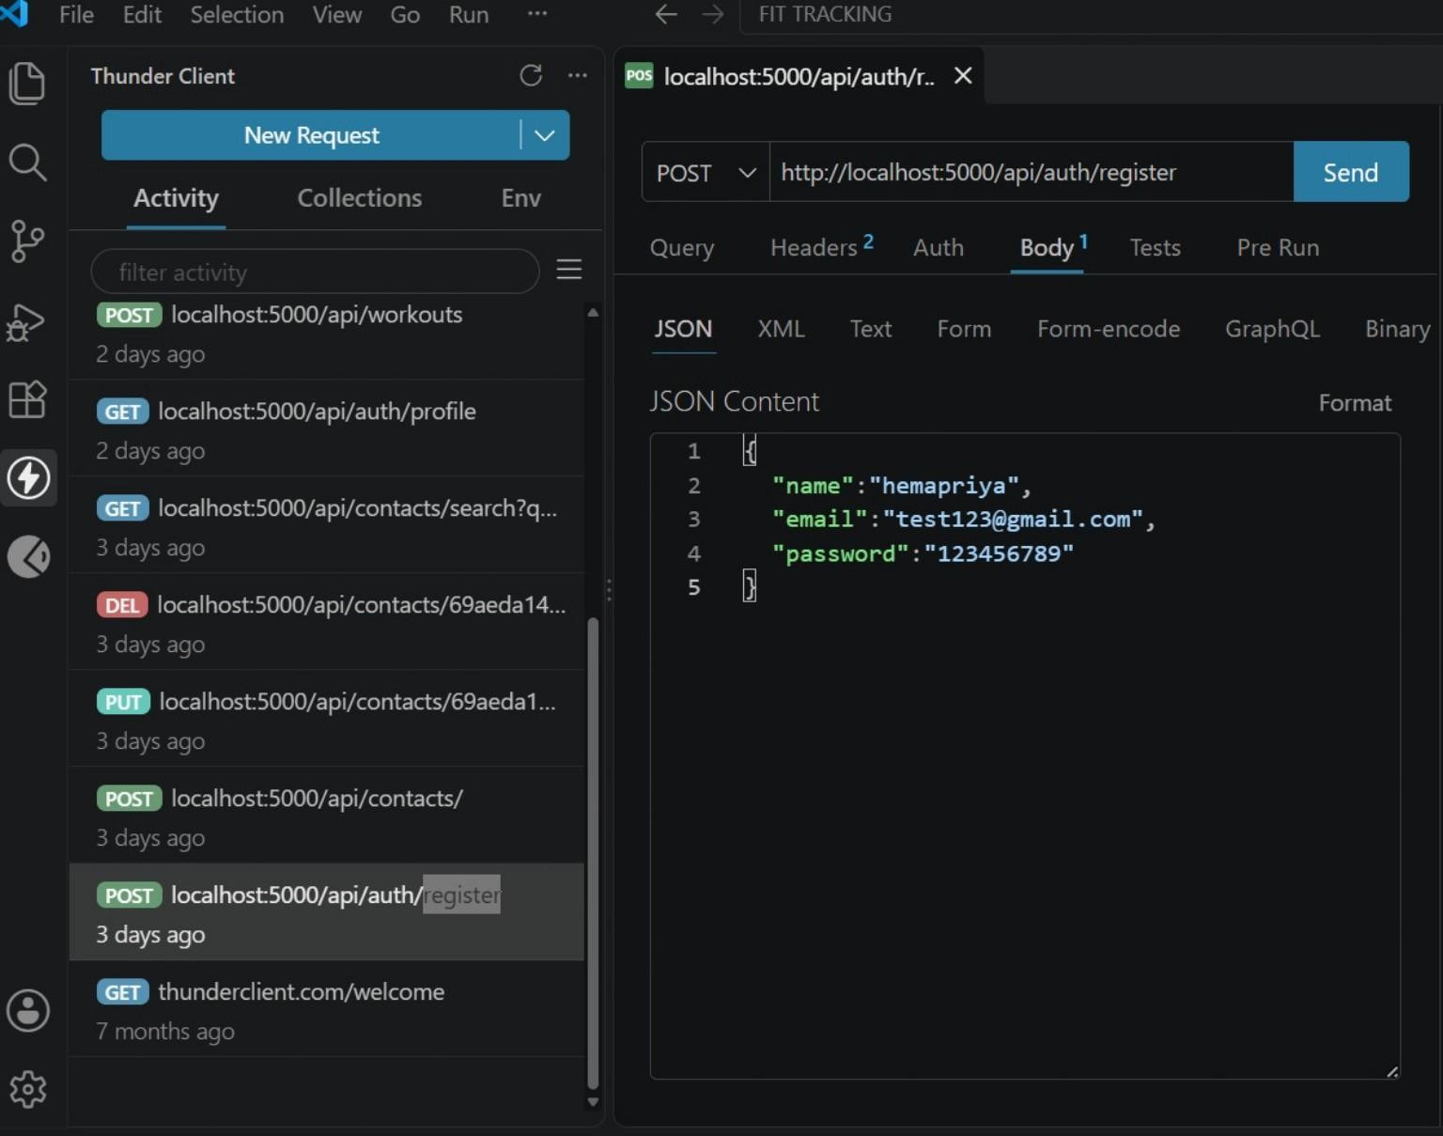

Seminar explanation: The registration API accepts the user's basic account information. The backend validates the request, hashes the password using bcrypt.js and stores the user in MongoDB.

  - Login User
Endpoint: POST http://localhost:5000/api/auth/login

Field | Example
email | test123@gmail.com
password | 123456789
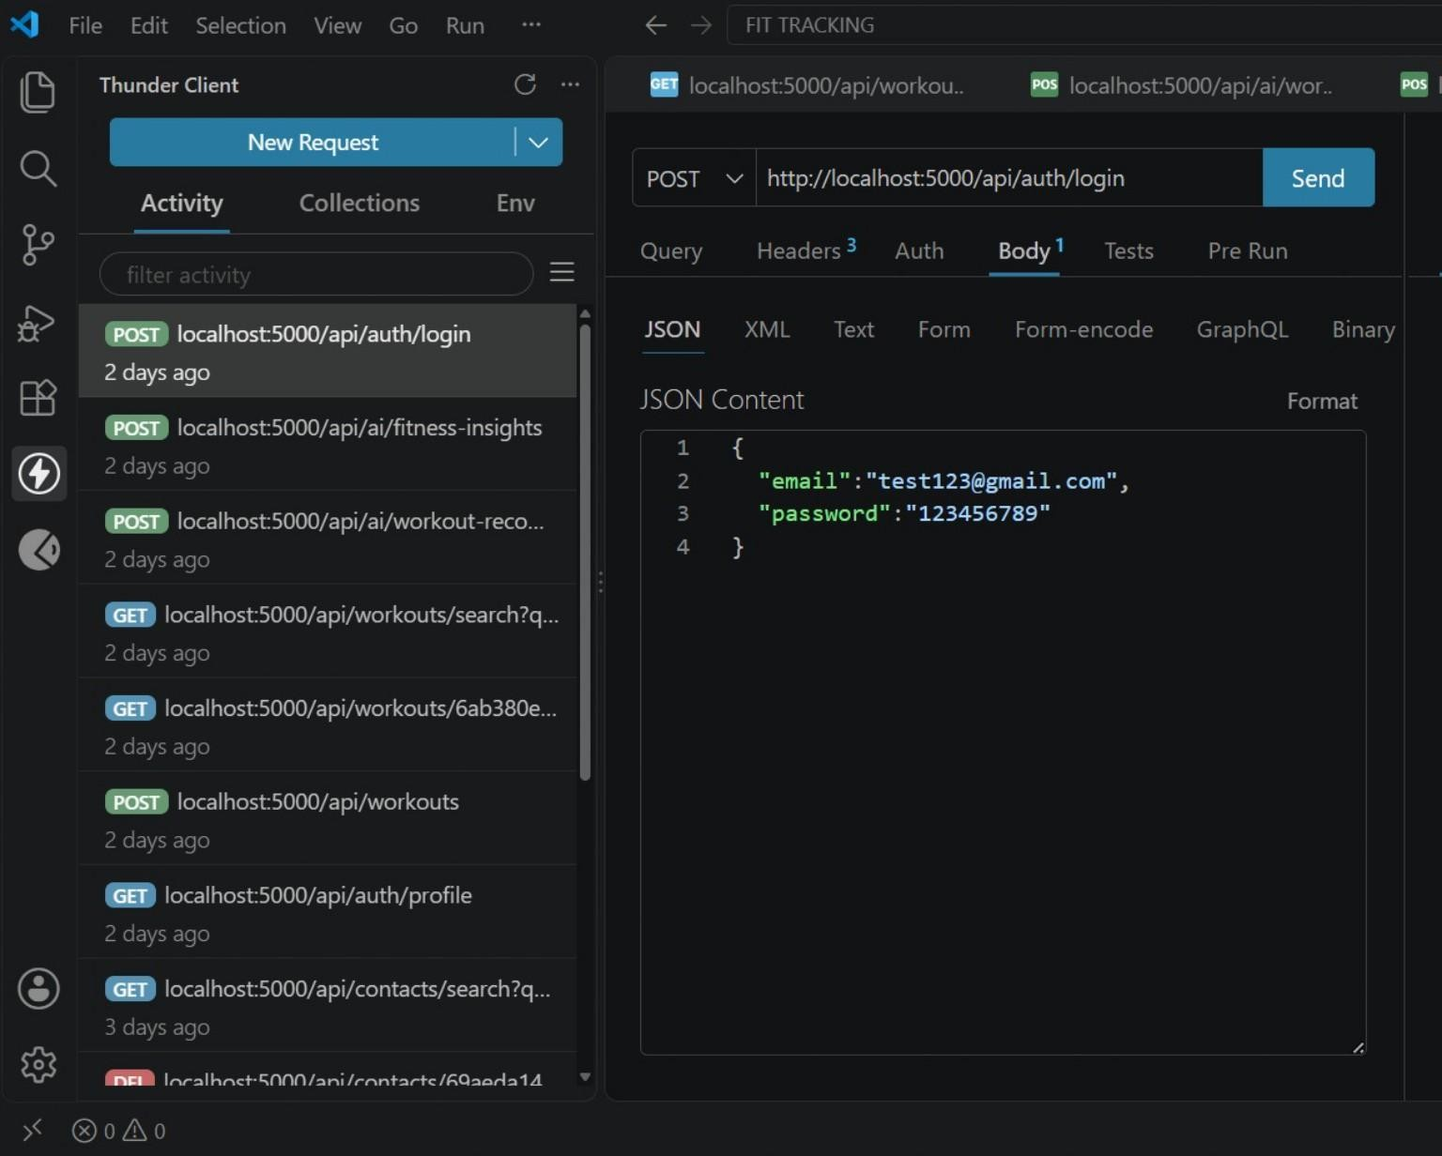
Figure 17.2 — Login User request in Thunder Client (supplied output screenshot).
Seminar explanation: A successful login authenticates the user and provides the JWT needed for protected endpoints. The screenshot demonstrates the request body used for authentication.

Get Profile

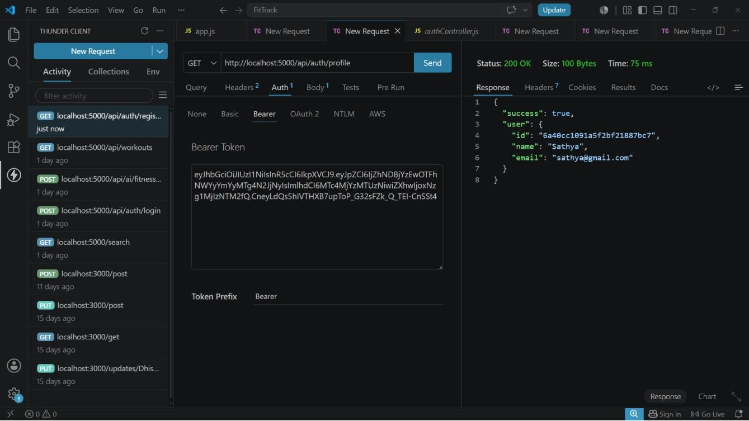

Seminar explanation: The profile endpoint demonstrates access to authenticated user information through the protected API layer.

- API Testing – Workout Outputs
  - Add Workout

Field | Example
workoutName | Running
category | Cardio
duration | 30
caloriesBurned | 250
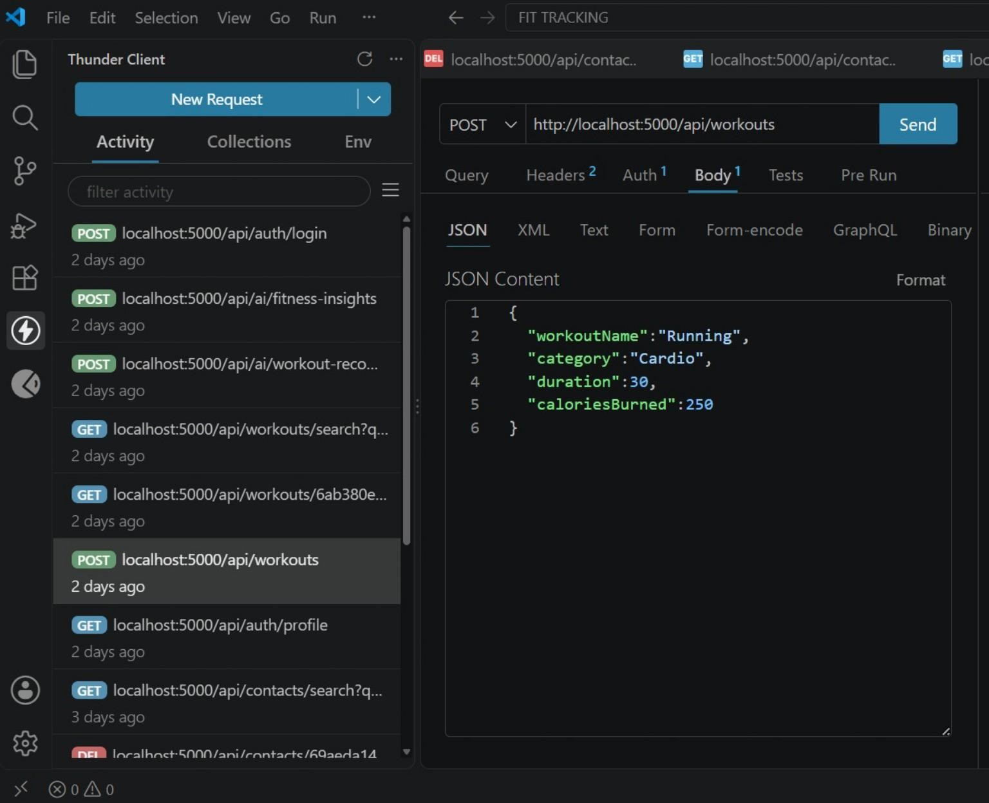

  - Get All Workouts

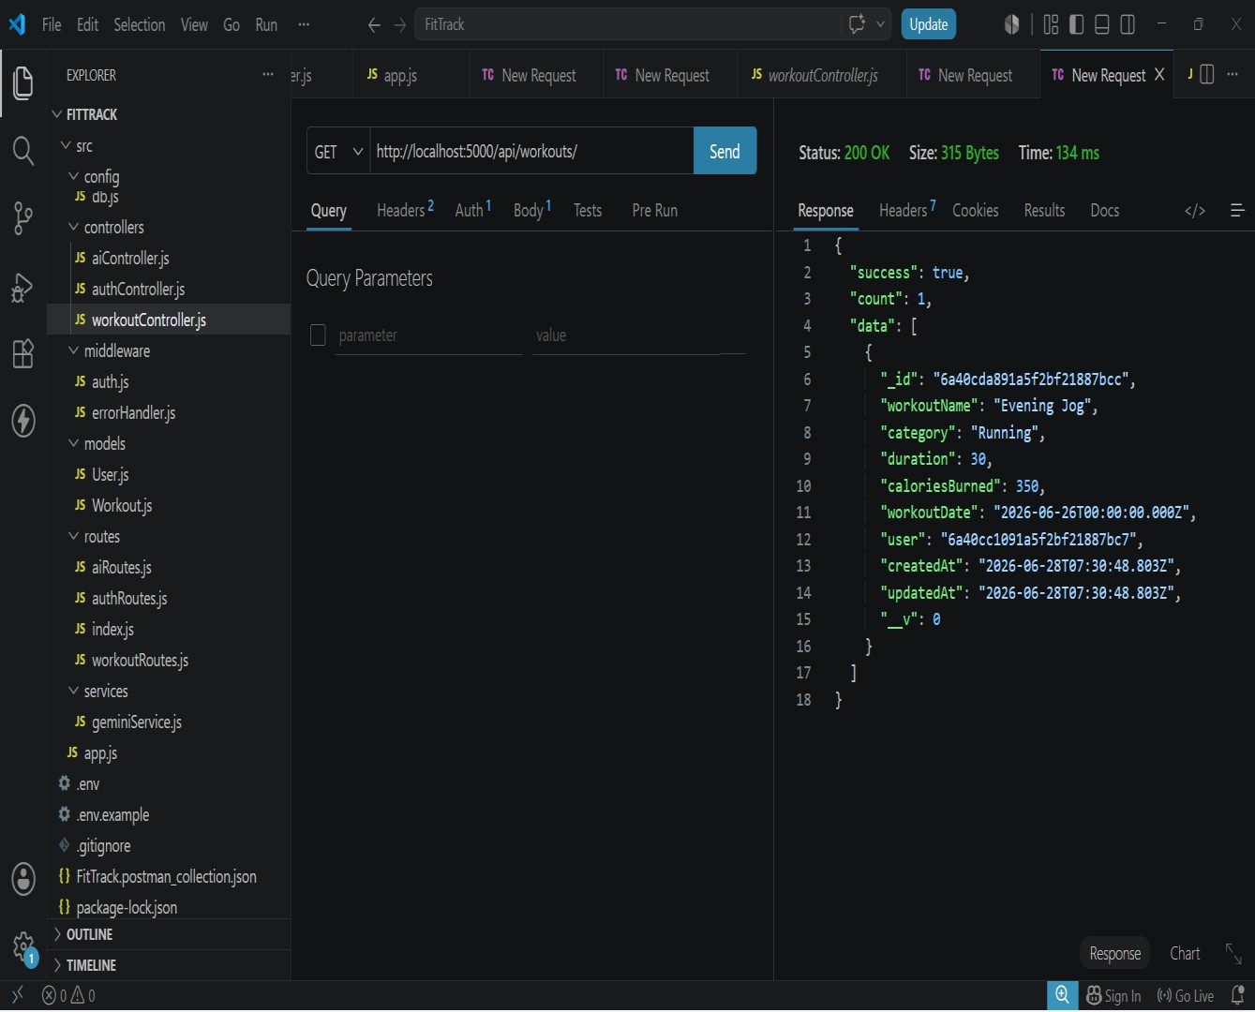

Seminar explanation: This endpoint returns the workout records associated with the authenticated user.

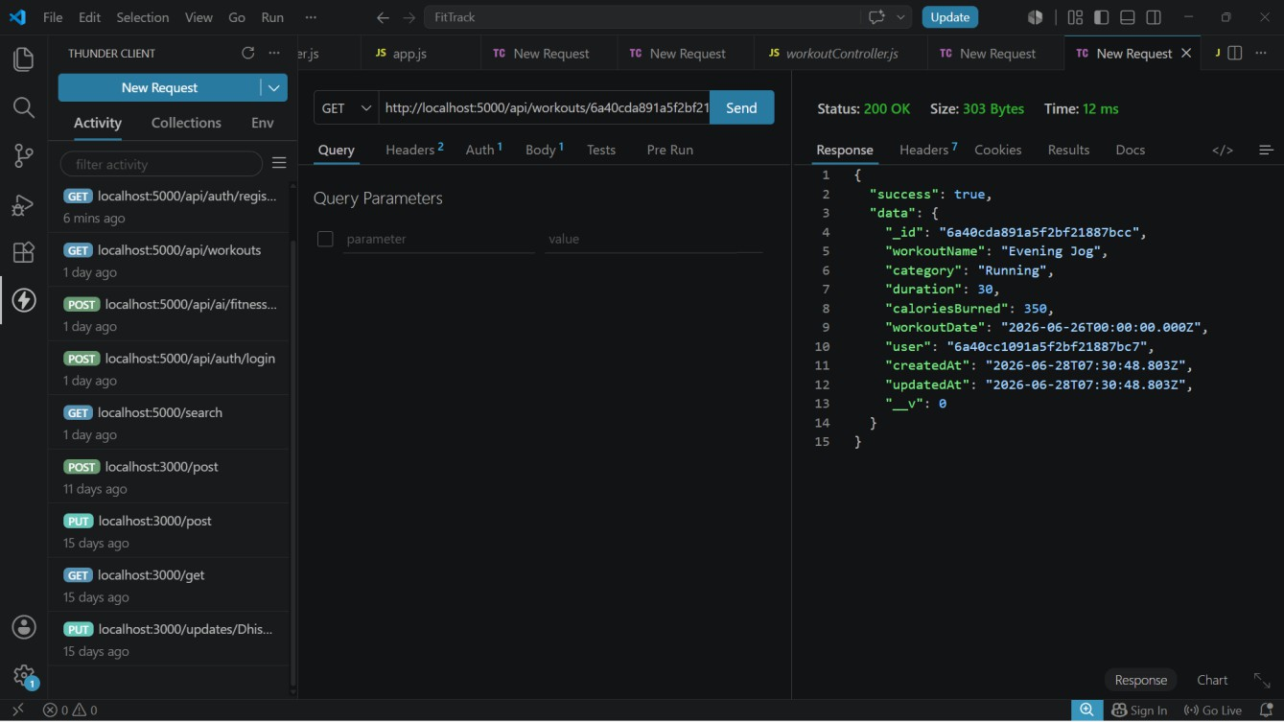

  - Update Workout

Field | Demonstrated update
workoutsName / workoutName | Running
category | Cardio
duration | 45
caloriesBurned | 250

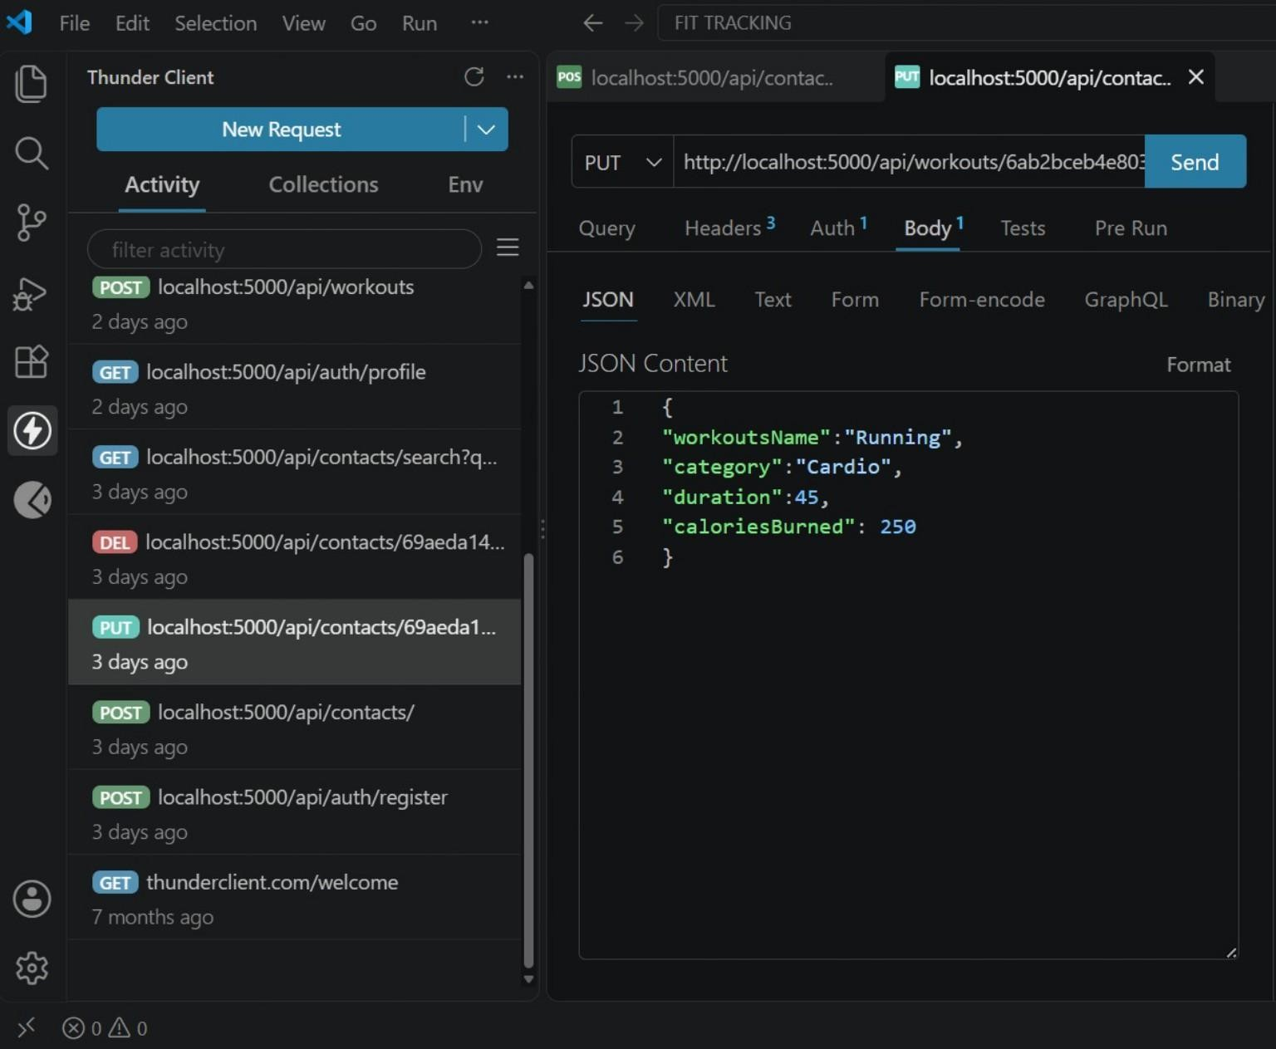

  - Delete Workout

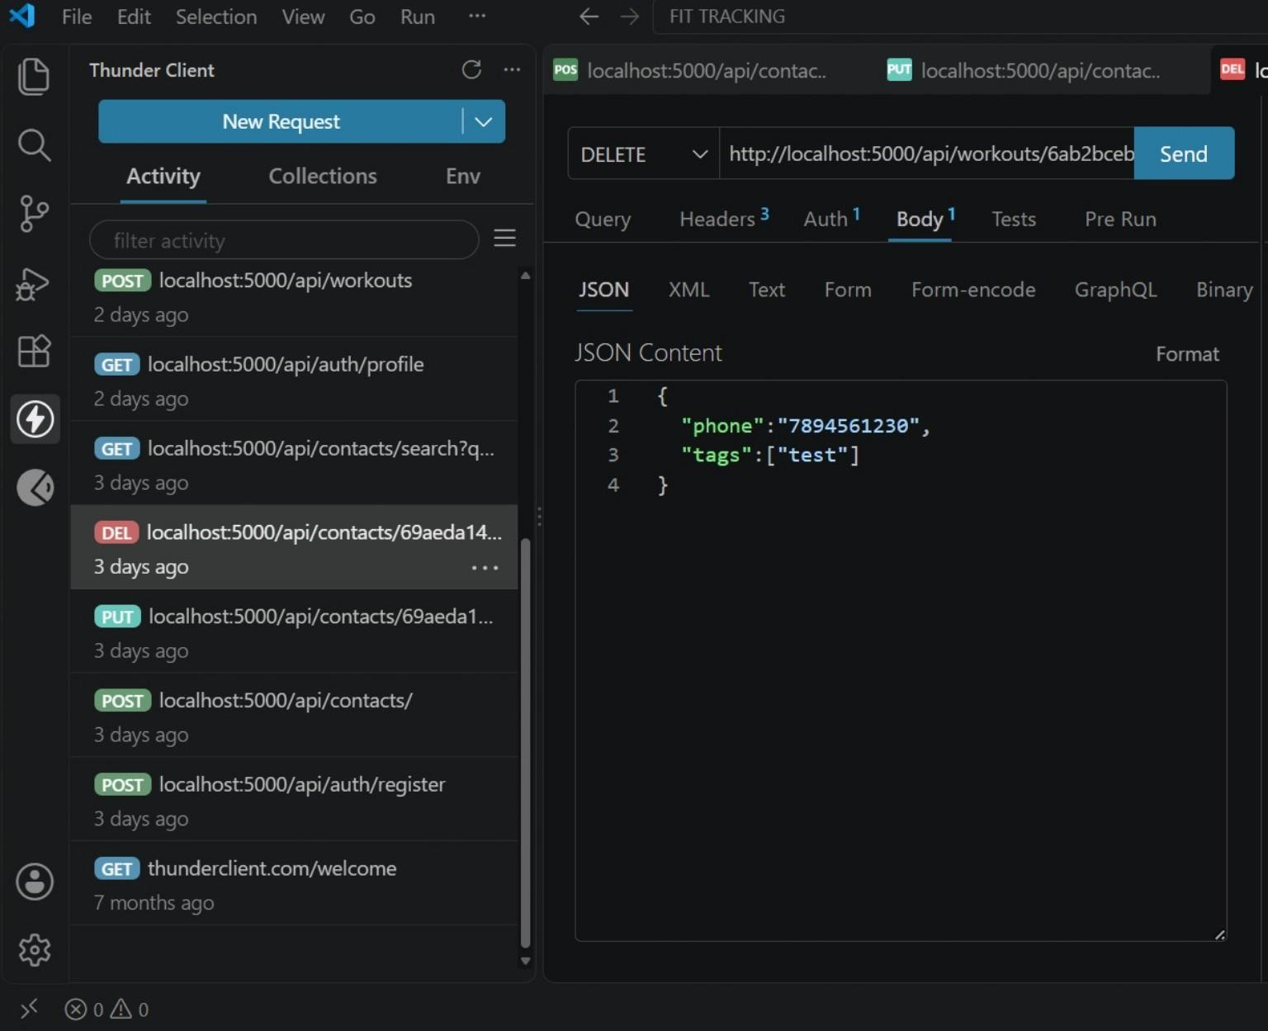
.
Seminar explanation: The delete operation removes the selected workout record. The response shown in the supplied screenshot confirms the operation at the API level.

- API Testing – AI Outputs

Field | Demonstrated value
age | 21
fitnessGoal | weightloss
experience | beginner
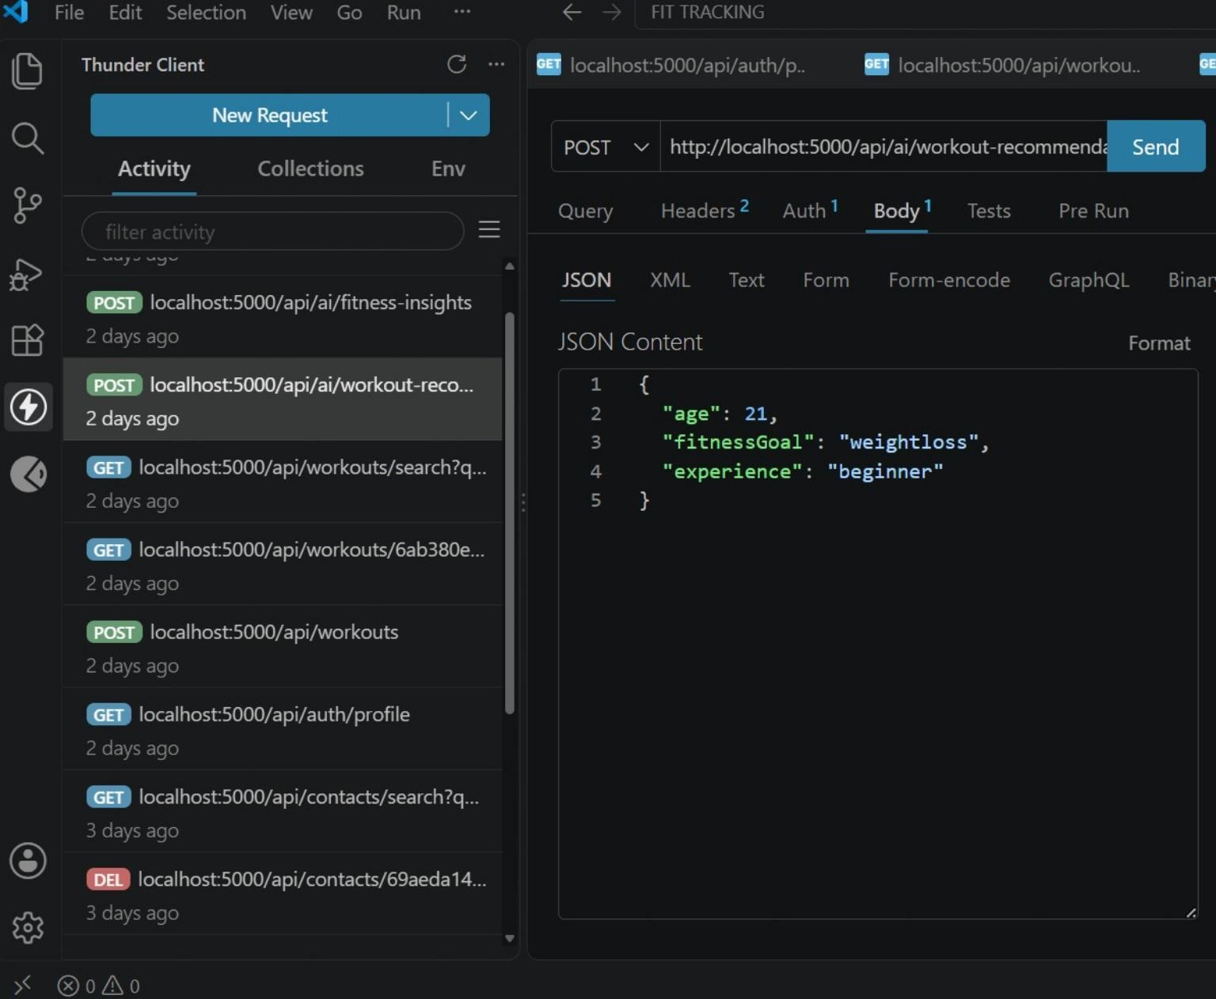

Seminar explanation: The request supplies age, fitness goal and experience level. The backend forwards the relevant information through the Gemini service and returns an AI-generated recommendation.

19.2 Fitness Insights

Field | Demonstrated value
totalWorkouts | 12
averageDuration | 45
totalCaloriesBurned | 3500
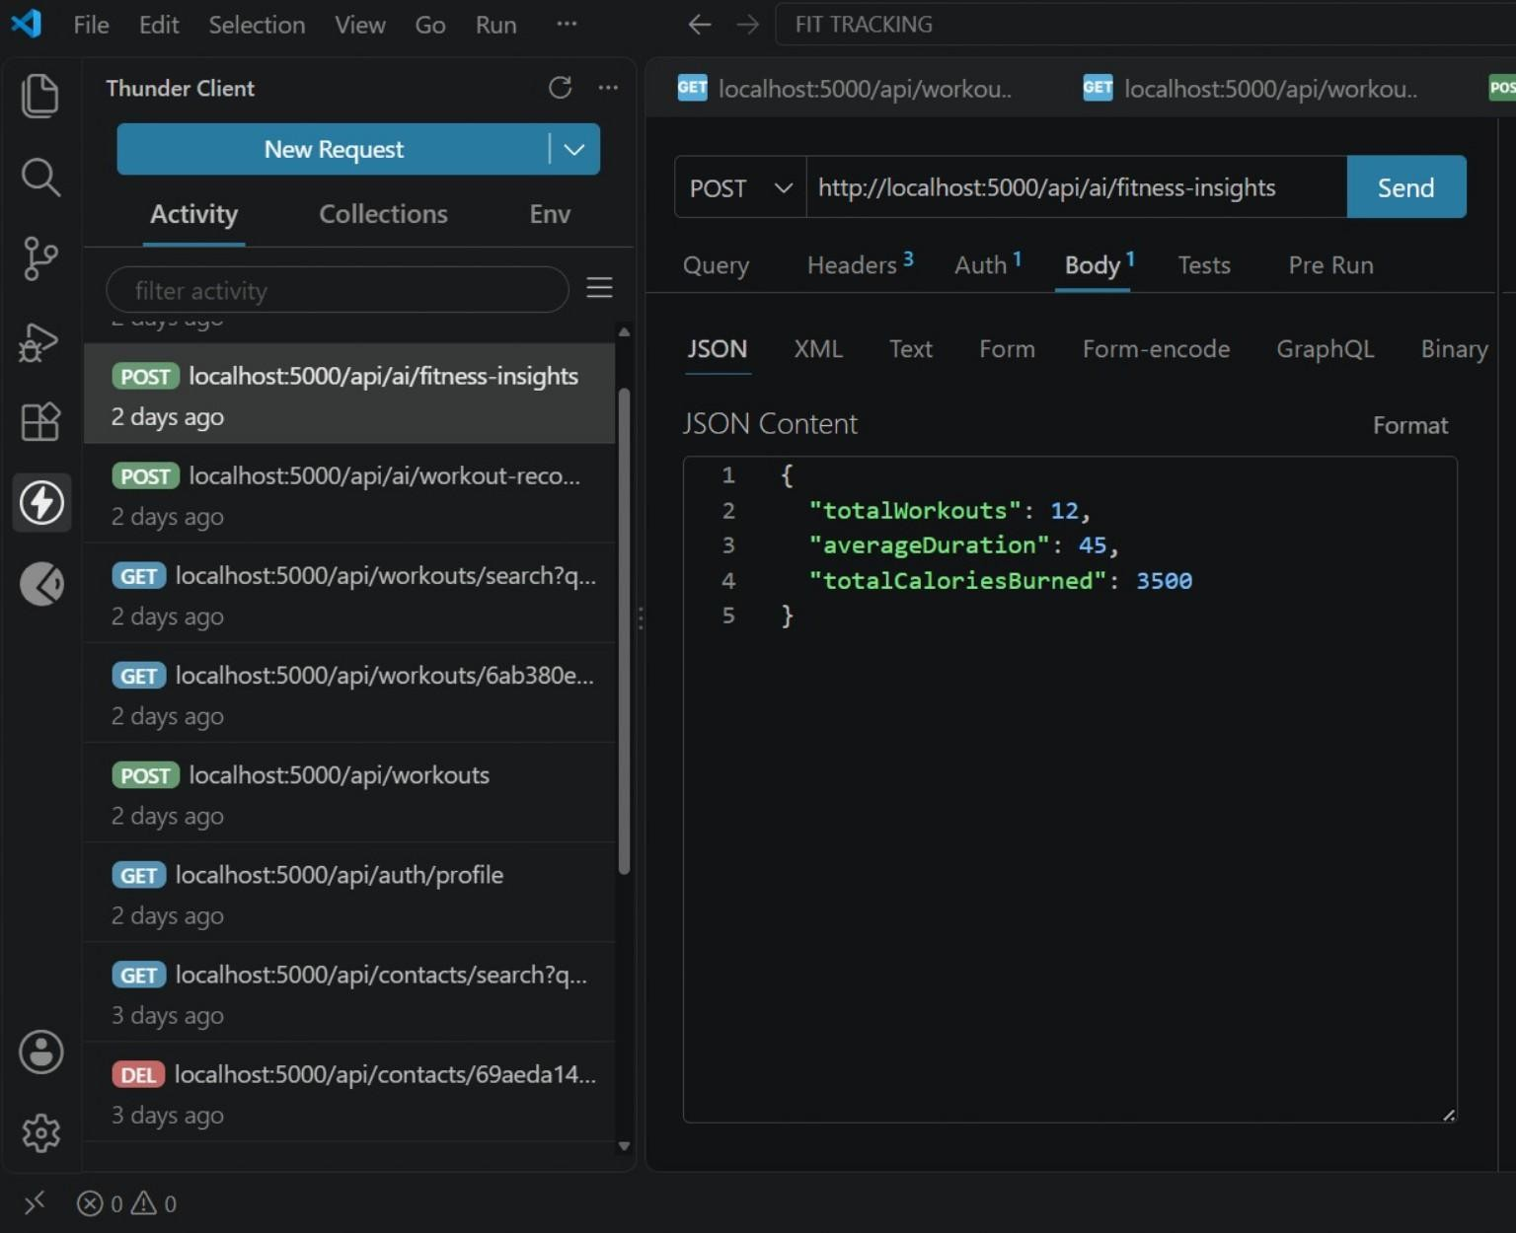

Seminar explanation: The endpoint receives workout statistics and uses the AI service to produce an interpretation of the user's activity.

- Error Handling, Validation and Reliability
The project document identifies centralized error handling as an important backend feature. The API is expected to return meaningful JSON error responses for common failure conditions.

Condition | Expected handling
Invalid credentials | Reject authentication  and return an error response
Missing authentication token | Reject protected request
Validation error | Reject invalid or  incomplete input
Database error | Return controlled error information
Internal server error | Return a standardized  server-side error response
Validation examples from the documented schemas:
- User name cannot be empty.
- User email must be unique.
- User password is mandatory and encrypted before saving.
- Workout name and category are mandatory.
- Workout duration must be greater than zero.
- Calories burned must be zero or greater.
- Workout date is required.

- Advantages, Limitations and Future Enhancements
Advantages
- Centralized and structured workout tracking.
- Secure authentication for personal data.
- Complete workout CRUD lifecycle.
- Searchable workout history.
- AI-powered personalized recommendations.
- AI-generated fitness insights.
- Modular MVC architecture.
- Suitable for web, mobile and third-party clients through REST APIs.
Limitations / Practical Considerations
- The demonstrated system is a backend API, so a separate frontend or mobile client is needed for a full end-user interface.
- AI responses depend on the quality and completeness of the input data and the configured Gemini service.
- Production deployment would require production-grade database, secret management, monitoring and API protection.
Future Enhancements
- Nutrition tracking.
- BMI calculation.
- Wearable device integration.
- Workout reminders.
- Fitness analytics dashboards.
- Richer progress visualizations.
- Additional role or administrative capabilities if required by the application.

- Conclusion and Seminar Talking Points

FitTrack AI presents a complete backend approach to modern fitness tracking. It combines secure authentication, MongoDB-based workout persistence, RESTful CRUD APIs and Google Gemini AI services in one modular architecture. The project document emphasizes maintainability, security and scalability through MVC separation, middleware, services and validation.
The supplied API testing screenshots demonstrate the practical execution of the system: users can register and log in, create and manage workouts, and submit fitness information to the AI endpoints. The testing sequence also makes it clear how each API belongs to a specific functional module.
Short Seminar Explanation

Question | Answer
1. What is FitTrack AI? | It is a secure, scalable RESTful backend for  workout tracking and AI-assisted fitness guidance.
2. Why is it needed? | It replaces scattered manual workout records  with centralized, searchable digital records and adds personalized AI assistance.
3. Which technologies are used? | Node.js, Express.js, MongoDB, Mongoose, JWT, bcrypt.js and Google Gemini AI.
4. What architecture is used? | MVC-based layered architecture separating  routes, middleware, controllers, services and models.
5. How is security handled? | JWT protects secured APIs and bcrypt.js encrypts passwords before storage.
6. What are the main workout operations? | Add, view, get by ID, search, update and delete.
7. How does AI work? | The backend sends user fitness inputs or workout statistics through a dedicated Gemini  service and returns the generated guidance.
8. How was the API tested? | Using Postman/Thunder Client with JSON request bodies and JSON responses.

Appendix A – API Test Evidence Map

Figure | API / Feature | Screenshot source used
17.1 | Register User | User-supplied  screenshot
17.2 | Login User | User-supplied  screenshot
17.3 | Get Profile | Supplied project-  document screenshot
18.1 | Add Workout | User-supplied  screenshot
18.2 | Get All Workouts | Supplied project-  document screenshot
18.3 | Get Workout by ID | Supplied project-  document screenshot
18.4 | Update Workout | User-supplied  screenshot
18.5 | Delete Workout | User-supplied  screenshot
19.1 | Workout  Recommendation | User-supplied  screenshot
19.2 | Fitness Insights | User-supplied  screenshot
The source project document also identifies Workout Search as a supported API. No separate search-output screenshot was supplied in the current materials, so this document describes the feature without inventing a visual output.

Appendix B – Source-Based Project Notes
This expanded seminar document is based on the supplied FitTrack AI project document and the API-output screenshots supplied with the request. The source document describes the backend, scenario, architecture, database model, features, setup, execution and API testing sequence.
- Project title: FitTrack AI – Personalized fitness recommendations powered by AI.
- Primary backend technologies: Node.js, Express.js, MongoDB and Mongoose.
- Security: JWT authentication and bcrypt.js password encryption.
- AI: Google Gemini integration for workout recommendations and fitness insights.
- Testing: Postman / Thunder Client.
- Testing order: Authentication APIs → Workout APIs → AI APIs.

